New STS-1 Electronics: Development and Test Results

Final report on Berkeley Seismological Laboratory’s part of the:
“Collaborative Proposal: development of new electronics, repair and testing procedures for very-broadband STS-1 seismometers”

IRIS Subaward Agreement number 388

July 11, 2007

Barbara Romanowicz, PI, Berkeley Seismological Laboratory
With contributions from Bill Karavas, BSL Principal Engineer, and Dr. Robert Uhrhammer, BSL senior seismologist.

Introduction
The STS-1 VBB (Wielandt and Streckeisen, 1982; Wielandt and Steim, 1986), widely viewed as the finest VBB sensor in the world, is currently the principal broad-band seismometer used by the Incorporated research Institutions for Seismology (IRIS) Global Seismographic Network (GSN), GEOSCOPE, and several other global or regional seismic networks operated by members of the Federation of Digital Broad-Band Seismograph Networks (FDSN). The installed base (approximately 750 sensor axes) represents a very significant international investment for low frequency seismology. The BDSN includes 10 STS-1's in its network. Unfortunately, many of the STS-1 seismometers, which were manufactured and installed 10-20 years ago, are encountering both operational failures and age-related errors (Ekström and Nettles, 2005). This problem is exacerbated by the fact that sensors are no longer being produced or supported by the original manufacturer, G. Streckeisen AG (Pfungen, Switzerland). The nature and severity of this problem has been discussed widely. For example, a report from a recent broadband seismic sensor workshop (Ingate et al, 2004) highlights the unique value of the installed base of STS-1 sensors, as well as the current lack of replacements with equivalent long period performance. In the absence of focused action by the seismological community, the state-of-health of the existing STS-1 instruments will continue to decline. Numerous efforts, both commercial and government-funded, are underway to develop future replacements (IRIS Workshop, 2004). Regardless of how one views the potential of these new approaches to delivering a manufacturable, STS-1-equivalent product, given the present funding environment, it is clear that they all would mandate outright replacements of the existing STS-1 sensors.
In February 2006, we initiated a project to develop and test new electronics and methods for mechanical repair for the STS-1 very broadband seismometer. This is a collaborative project with Tom VanZandt of Metrozet, LLC (Redondo Beach, CA) and has been funded by a grant from NSF through the IRIS/GSN program.
A primary goal of this effort was to develop a fully-tested, modern electronics module that will be a drop-in replacement for the original electronics. This will provide users with a legitimate option for replacing old modules that are no longer functioning. This new electronics design addresses environmental packaging problems that have led to operational errors and failures in the existing instruments. This effort also provided the opportunity to implement a set of electronic improvements that will make the installation and operation of the sensors more efficient.
In the first half of 2006, Metrozet developed the first prototype and reverse engineered electronics for the STS-1, while the BSL engineering staff constructed a test-bed at the Byerly Vault (BKS) and developed the capability to simultaneously test 6-8 STS-1 components. The next 8-10 months were spent by BSL staff testing successive versions of the electronics. In the final stage of the project, once the BSL tests were completed and the development appeared complete and satisfactory, the new electronics were finally tested at the Albuquerque Seismological Laboratory’s seismic vault, which is located in a quieter environment than BKS.

From the perspective of BSL, the critical task in development of new electronics for the STS-1 seismometers was the performance evaluation and comparison of new to the old. Several iterations of the design and configuration would be evaluated during the design and development phase.

Objective evaluation of the new electronic subsystem required a stable and repeatable test platform of seismometers, baseplates, cables, connectors and digitizer channels. Only when the system was stable as evidenced by repeated calibration results, was the platform suitable for evaluation of the new electronics.

In practice, this required separate objective evaluations of both the data logger and seismometer subsystems. To enable characterization of the new seismometer electronics over the widest bandwidth, an eight channel Quanterra Q4120 was configured to 200hz sampling. Prior to connecting the seismometers, the data logger was evaluated for individual channel sensitivity, self-noise, and channel cross-talk isolation. During these data logger tests, the system power supply failed, and some individual data channels were found to be noisy or not working at all. Ultimately, the datalogger was completely swapped. Each failure and repair necessitated running through the calibration procedure completely from start to finish. Likewise these tests were repeated after any reboot of the datalogger, and at the conclusion of the evaluation of overall testing.

Having characterized and calibrated the data logger, it was necessary to establish a stable seismometer subsystem test bed. Nine different STS1 instruments (six horizontal, and three vertical instruments) were set up, leveled, and the outputs to the Q4120 data logger quantitatively compared.
The horizontal instruments were aligned along a single axis enabling coherency comparisons and evaluations. Misalignment of less than one degree across the six horizontal instruments caused unacceptable variances in signal coherency, and took a week to resolve by rotation of individual instruments. Alignment of the vertical instruments was much easier. Only after all alignment incoherences were resolved were the new electronics evaluated against the old original.

Each cable, connector, and baseplates combination were marked, color coded and assigned as new and original electronics were mated with seismometers. The color coding endeavored to eliminate ambiguities and variables beyond the actual electronics. Each combination of seismometers and electronics were recorded for a minimum of 24 hours. In the end, over 100 combinations of original and new electronics and seismometers were evaluated under conditions that were documented and evaluated.

Only after individually labeled and identified combinations of baseplates, cables, seismometers, and electronics were characterized and deemed repeatable, were the new Metrozet electronic substituted. Initially, the prototype Metrozet electronics were operated on only one seismometer with three, four or five other seismometers simultaneously operating on Streckeisen's factory electronics. After verifying correct input and output signal levels, the single Metrozet electronics were rotated and verified amongst six seismometers. A second prototype Metrozet electronics was likewise rotated through the electronics, but this time powering two seismometers concurrently.

The first generation prototype electronics did not include provision for activating or controlling the seismometers centering motor. The second generation prototype included the motor control functionality. The second generation prototype was again rotated amongst the instruments and functionality verified.

Finally, a third generation prototype, built on the earlier generations, included calibration functions. After some observations and refinements, this generation of electronics was operated on two seismometers concurrently and successfully run through the swept and stepped calibration functions on four seismometers. During this final phase, the Metrozet electronics included the ability to initiate and operate the calibrations via a RS232 serial connection. Most of the calibration testing was performed remotely from Metrozet's Southern California office over the BSL network. Metrozet was able to remotely log into the Berkeley network, establish a connection to the test bed in the Byerly seismic vault, initiate control of the seismometer including remote centering and calibration functions. During this period, BSL staff swapped the Metrozet electronics between four seismometers at Byerly vault.

As a result of the calibration of the data logger, alignments of the seismometers, and documentation of individual cables, connectors, baseplates etc, the resulting combinations of individual electronics and seismometers yielded repeatable results.

Sensor Testing Facility

Prior to the initiation of this project, the BSL had set up an Instrumentation Test Facility in the Byerly Seismographic Vault in order to systematically determine and to compare the characteristics of up to eight sensors at a time. The test equipment consists of an eight-channel Quanterra Q4120 high-resolution data logger and a custom interconnect panel that provides isolated power and preamplification, when required, to facilitate the connection and routing of signals from the sensors to the data logger with shielded signal lines. This year a GPS rebroadcaster was installed, so that all data loggers in the Byerly vault would operate on the same time base. Upon acquisition of data up to 200 samples-per-second (sps) from the instruments under test, PSD analysis, coherence analysis and additional ad hoc analysis algorithms are used to characterize and compare the performance of each sensor. Tilt tests and seismic signals with a sufficient signal level above the background seismic noise are also used to verify the absolute calibration of the sensors. A simple vertical shake table is used to assess the linearity of a seismic sensor.
The sensor testing facility of the BSL is described in detail in the BSL 2001-2002 Annual Report (available on line at http://www.seismo.berkeley.edu).

STS-1 Electronics Development
Data Logger Calibration
Prior to the tests on the new STS-1 electronics, the Instrumentation Test Facility eight-channel Quanterra Q4120 data logger (s/n 103064) had been employed in BDSN operation for 8 years. In July 2004, it was repaired and the calibration checked by the factory. At the beginning of the test, the sensitivity, noise floor and crosstalk of the data logger was checked using a reference signal applied first simultaneously and then sequentially to all channels with the non-driven channels terminated. The relative sensitivities of the data logger channels were checked by applying a high-level (~19.8 V peak-to-peak) 1 Hz square wave signal simultaneously to all channels. The signal level on each channel was measured and the relative signal levels were compared to the sensitivities on the factory calibration sheet. The results are given in Table 1. The sensitivities of four of the channels have not changed by more than 0.01% from the factory calibration values. Of the remaining four channels, three changed by less than +/-0.3% and the fourth changed by -0.8%.

Table 1. Quanterra Q4120 Calibration Check. Deviation is relative to the median inferred drive level of 19.791624 Volts.

Channel | Factory DU/V | P-P counts | Est P-P volts | Deviation (%)
1 | 403640 | 8012274 | 19.850050 | -0.29
2 | 435388 | 8689678 | 19.958469 | -0.83
3 | 437149 | 8651000 | 19.789591 | +0.01
4 | 422829 | 8365690 | 19.785043 | +0.01
5 | 420706 | 8314894 | 19.764144 | +0.14
6 | 430613 | 8548404 | 19.851709 | -0.30
7 | 438570 | 8680904 | 19.793657 | -0.01
8 | 434817 | 8600236 | 19.778978 | +0.01

The inter-channel cross-talk was checked by connecting each of the channels in sequence with the high amplitude (20 V P-P) 1 Hz square-wave signal while terminating the other seven channels. The Q4120 data logger contains two 4-channel digitizer modules (HH1-HH4 and HH5-HH8). The observed cross-talk signal on all 8 channels is below the 2.38 V quantization level of the Q4120 data logger. The cross-talk is thus more than 138.5 dB below the drive signal level. A check of the coherence between the channels was performed by driving channel HH1 with a one minute duration 20 V P-P 1 Hz square wave while terminating channels HH2-HH8 with 1k resistors. A spectral phase coherency analysis of the signal between selected channels (HH1-HH2, HH3-HH4 and HH5-HH6) shows that there is a coherent phase comb present with peaks at 1 Hz and its odd harmonics as shown in Figures 1-3, where HH1 is driven with the 1 Hz square-wave and the other channels are terminated with a 1k resistor. The time series are one minute long and the phase data have been heavily filtered to enhance the phase structure. The Q4120 data logger contains two 4-channel digitizer modules (HH1-HH4 and HH5-HH8). The HH1-HH2 plot shows a significant phase coherency structure (HH1 is driven) while the HH3-HH4 plot has some coherent structure and the HH5-HH6 plot has little coherent structure.
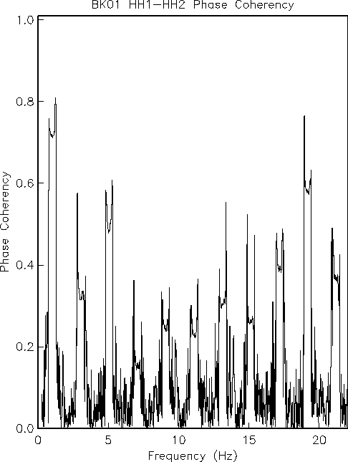

Figure 1. HH1-HH2 phase coherency as a function of frequency. HH1 is driven with a 20 V P-P square wave and HH2 it terminated with a 1k resistor. The RMS signal level at 1 Hz on HH2 is below the 2.38 microvolt LSB of the digitizer. Even though the HH2 signal level is below 1 LSB, the phase spectra shows a definite comb structure at 1 Hz and its odd harmonics. The phase data are smoothed using a 0.2 Hz wide boxcar filter.

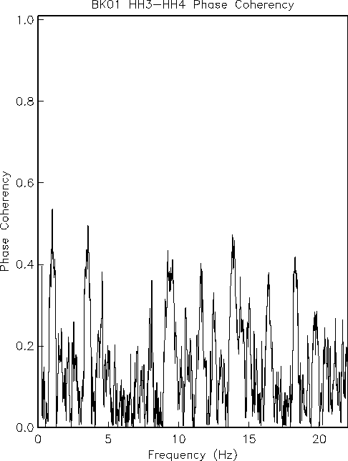
Figure 2. HH3-HH4 phase coherency as a function of frequency. HH1 is driven with a 20 V P-P square wave while HH3 and HH4 are both terminated with 1k resistors. HH3 and HH4 are on the same digitizer module as HH1. The RMS signal levels at 1 Hz on HH3 and HH4 are below the 2.38 microvolt LSB of the digitizer. Even though the signal levels are below 1 LSB RMS, the phase spectra hints at a comb-like structure with peaks at 1 Hz and some of its odd harmonics. The phase coherency levels are not significant, however.
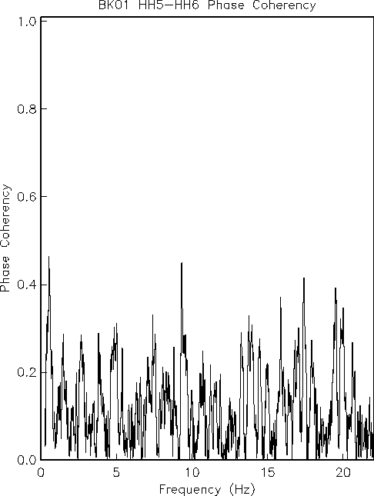
Figure 3. HH5-HH6 phase coherency as a function of frequency. HH1 is driven with a 20 V P-P square wave while HH5 and HH6 are both terminated with 1k resistors. HH3 and HH4 are on a different digitizer module than HH1. The RMS signal levels at 1 Hz on HH5 and HH6 are below the 2.38 microvolt LSB of the digitizer. The phase coherency levels are not significant.
Seismometer Acquisition and Alignment

After the data logger was calibrated, it was necessary to establish a stable seismometer subsystem test bed. Nine different STS1 instruments (six horizontal, and three vertical instruments) were set up, leveled, and the outputs to the Q4120 data logger quantitatively compared. The horizontal instruments were aligned along a single axis enabling coherency comparisons and evaluations. Misalignment of less than one degree across the six horizontal instruments caused unacceptable variances in signal coherency, and took a week to resolve by rotation of individual instruments. Alignment of the vertical instruments was much easier. Only after all alignment incoherences were resolved were the new electronics evaluated against the old original.

Sensor/Electronics Testing
Testing of the STS-1 sensor and electronics systems involved several components. STS-1 vertical- and horizontal-component sensors for testing were gathered from among the available BDSN sensors, from surplus sensors on loan from the Graffenberg Array and from UC San Diego. The sensors were systematically inspected and checked for nominal operation and the ones that performed the best were selected for the testing procedures and installed in the test bed.
Sensors
The following broadband STS-1 sensors were utilized during the testing procedures. The horizontal-component sensors were aligned East.

Serial Number | Component | Source | Note
9 | V | GRF | 1
13 | V | GRF | 1
14 | H | GRF | 1
18 | H | GRF | 1
unknown | V | GRF | 1
18718 | H | IGPP/UCSD | 2, 3
29201 | H | BSL | 4, 7
29212 | H | BSL | 4, 7
38502 | V | BSL | 3, 4, 7
38505 | V | BKS Reference | 3, 5
39010 | H | BSL | 4
39039 | H | IGPP/UCSD | 2, 3, 6, 7
48530 | H | BSL | 3, 4
48531 | H | BKS Reference | 3, 5
109112 | V | BSL | 4, 7
109124 | V | BSL | 4, 7

1 - Graeffenberg (GRF) sent five seismometers total; three vertical, and two horizontal sensors. These BB instruments were some of the earliest produced by Streckeisen. While the sensors themselves are nearly identical to the later VBB instrument Streckeisen produced, the connector, and electronics are sufficiently different that these were not used as part of the response test bed. These instruments were extremely useful in evaluation of hinges, manufacture and assembly of these instruments. Graeffenberg also provided shielding, vacuum enclosures and warpless base plates that were used.
2 – IGPP/UCSD sent two horizontal seismometers.
3 - These sensors were shipped from Streckeisen as 20 sec BB seismometers and later upgraded to 360 sec VBB seismometers.
4 – BSL provided STS-1 seismometers.
5 – These co-sited BKS STS-1's in the Byerly Seismic Vault are used as reference.
6 – Sensor was shipped with a mismatched Streckeisen electronics box (s/n 6824).
7 – These STS-1's were ultimately selected and used in the test bed.

Coherence and Power Spectral Density
An algorithm (scn_psd) to calculate the signal Power Spectral Density (PSD), the noise PSD and the coherence between sensors has been developed as a tool for quantifying the performance differences between the seismic sensors under test. Two sample results of the algorithm are shown. Figure 4 shows the results for four seismometers in the case of a large seismic event and Figure 5 shows the results for four seismometers in the case of background noise.
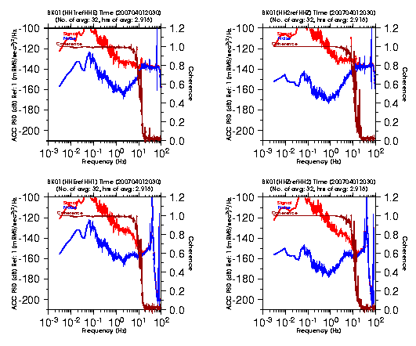
Figure 4. Results for two vertical component STS-1's (HHZ and HH2) and two horizontal component STS-1's (HHE and HH1) in the presence of a large seismic signal. The event is a Mw 8.1 earthquake which occurred 87.9 degrees WSW of Berkeley on 2007/04/20 at 20:39 UT. Shown are the signal PSD (red), the noise PSD (blue) and the coherence (brown) for each sensor. In all tests, the BKS STS-1's are used as the reference signals in the analysis. In the presence of large seismic signals the coherence is typically close to unity at all frequencies below the 5 Hz high-frequency corner of the BKS reference STS-1's. Note the relatively high noise PSD level on the horizontal components in the vicinity of 0.1 Hz. This is due to a slight misalignment of the sensitive axes of the horizontal components. Several time consuming trial and error iterations in aligning the horizontal components are required to lower the horizontal component noise PSD.
Three continuous hours of 200 Hz data are used by the scn_psd algorithm. scn_psd parses the data into 32 non-overlapping samples, applies a hanning window, corrects for the effects of the hanning window, scales the data to ground motion, calculates the FFT and stores the resulting complex spectral values for each sample. At each frequency, the RMS signal PSD is calculated from the average of the complex spectral values, coherence is calculated from the averaged complex spectral cross product, and the RMS noise PSD is then determined from the product of the signal PSD and ( 1 – coherence). The method is described in detail in Gardner (1992).

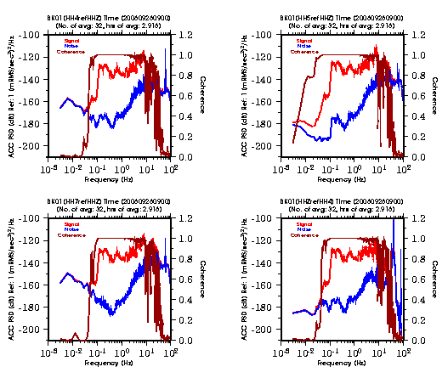
Figure 5. Results for four vertical component STS-1's (HHZ, HH4, HH5, and HH7) in the presence of background noise. The traces are the same as in Figure 4. The lower and upper frequencies at which the coherence degrades from near unity varies among the sensors. Coherence bandwidth is a measure of the performance of the sensors and HH5 has the best performance of the four sensors.

Free Period and Damping
Algorithms were developed to determine the free period (Ts) and fraction of critical damping (hs) of the seismometer and to determine the high-frequency corner of the seismometer. The free period and fraction of critical damping were determined via a grid search for the maximum variance reduction between the observed spectral phase response and the theoretical spectral phase response to an acceleration step input signal. A sample output of the algorithm is shown in Figure 6 and the results from several sensors are listed in Table 2. The algorithm performs best when the acceleration step is 60+ dB above the low-frequency background noise level.
The high-frequency corner of the seismometer was determined from the response to a 1 Hz square wave. The square wave signal was stacked to improve the SNR and the high frequency corner (fg) and fraction of critical damping (hg) were determined via a grid search for the maximum variance reduction between the observed spectral phase response and the theoretical spectral phase response to the stacked square wave signal. A sample output of the algorithm is shown in Figure 7.
Table 2. Results of acceleration step test determination of Ts and hs and their respective standard errors seTs and sehs.
Date | Station | Comp | Ts (sec) | seTs | hs | sehs | Peak  signal | SNR  (dB)
20060925 | BKS | Z | 352.9 | 23.56 | 0.676 | 0.0226 | 6554 | 21.43
 | BKS | N | 361.0 | 322.40 | 0.596 | 0.2661 | 12141 | 23.93
 | BKS | E | 347.5 | 192.21 | 0.752 | 0.2080 | 8564 | 23.93
20060928 | ORV | Z | 358.6 | 2.14 | 0.707 | 0.0021 | 284534 | 62.39
 | ORV | N | 358.3 | 5.19 | 0.709 | 0.0051 | 359999 | 64.69
 |  | E | 360.0 | 2.73 | 0.706 | 0.0027 | 343220 | 61.27
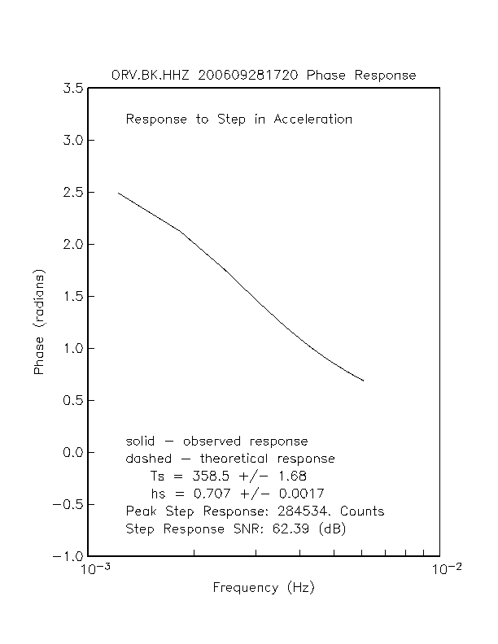
Figure 6. Sample plot of the low-frequency spectral phase response. With 60+ dB acceleration step signal-to-noise ratios, the free period (Ts) and the fraction of critical damping (hs) are resolvable to within ~0.5 percent and ~0.25 percent respectively.
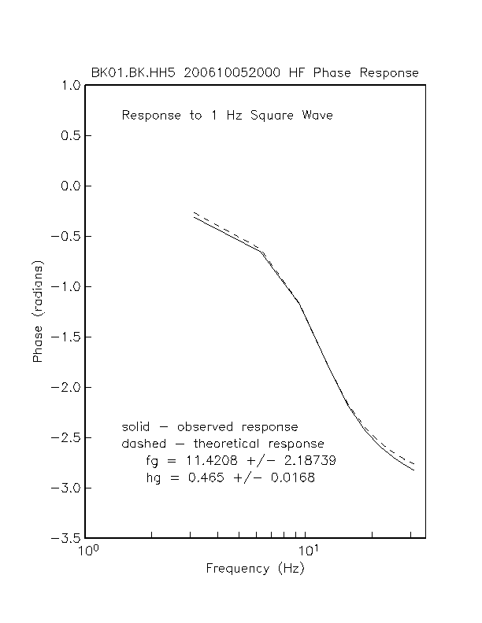
Figure 7. Sample plot of the high-frequency spectral phase response. The ability to resolve the effective high-frequency corner (fg) and fraction of critical damping (hg) is limited by the presence of cultural background noise in the vicinity of the Byerly Vault.

Field Testing at BDSN Station at Hopland (HOPS)
On June 7, 2007, a Metrozet STS-1-E300-10-005 electronics box was installed in place of the Streckeisen factory supplied electronics boxes on the three STS-1 broadband seismometers operating at HOPS. As a result of this change, the flat pass band sensitivities of the STS-1 BRB and LP outputs changed as shown in Table 3.
Table 3. HOPS STS-1 Sensitivity Comparison.
Comp | Serial No. | Streckeisen BRB V/(m/s) | Streckeisen LP V/(m/s²) | Metrozet BRB V/(m/s) | Metrozet LP  V/(m/s²) | BRB  Change
Z | 109114 | 2452 | 83.4 | 2386 | 80.5 | -2.7%
N | 29219 | 2284 | 77.4 | 1984 | 66.9 | -13.1%
E | 29215 | 2304 | 78.0 | 1993 | 67.0 | -13.5%

The Metrozet sensitivities were calculated using the STS-1 Calibration Software Applet supplied by Metrozet.
A M 2.4 local earthquake occurred, at (2007.159.145420 UT) in the Geysers geothermal field 31 km SE of HOPS, less than a day after the Metrozet electronics was installed and it was recorded by both the STS-1 and the co-sited accelerometers. Figure 8 compares the vertical component P-wave absolute ground acceleration inferred from the STS-1 and from the accelerometer. The data have been 5-8 Hz 6PBP filtered to enhance the SNR. At the dominant 7.3 Hz frequency of the waveforms in the plot, the STS-1 inferred ground accelerations are 13.2 percent larger and phase advanced by 13 msec relative to the co-sited accelerometer inferred ground accelerations. The primary reason for this is that the STS-1's high-frequency corner has changed and it has not been accounted for in the transfer function. A calibration procedure was performed to determine the seismometer free period (Ts) and fraction of critical damping (hs) and the high-frequency corner (fg) and fraction of critical damping (hg) of the new system (STS-1 with E300 electronics). This sweep calibration was invoked remotely from Berkeley, and yielded the following results:

Comp Ts hs fg hg C
Z 360.08 0.6768 15.00 0.371 0.00939
N 362.93 0.6889 16.28 0.328 0.00909
E 388.37 0.9920 16.29 0.343 0.00844

The constant “C“ above is an empirically derived scaling factor which scales the stimulus signal so that the calculated times series best agrees with the observed time series in a least-squares sense. "C" is
proportional to the product of the calibration coil generator constant, the flat passband velocity sensitivity of the seismometer and the sensitivity of the data logger.
This and other tests allowed the development of recommendations for the use of the new remote calibration procedures provided with the Metrozet E300 electronics.

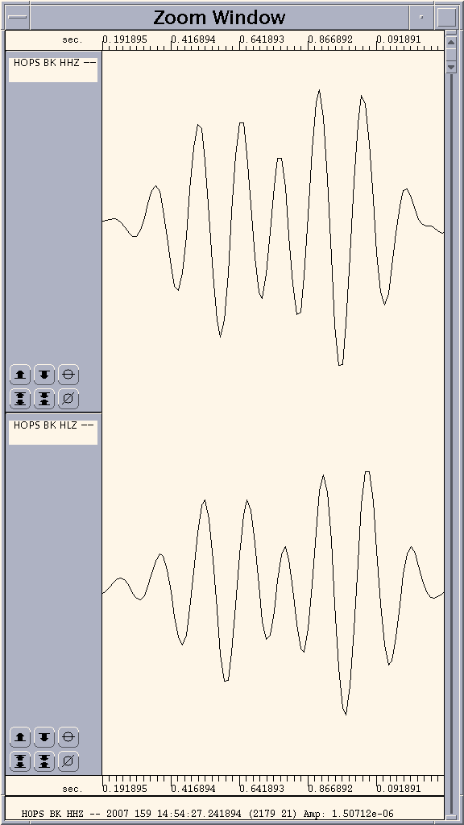
Figure 8. Comparison of the Z-component local earthquake P-wave ground acceleration at HOPS inferred from the STS-1 and from the co-sited accelerometer.

Sensor Testing Timeline

The performance testing at BSL occurred in stages with most work being performed between July 2006 and January 2007. The calibration of the data logger took over three weeks due to a number of back to back system failures including the power supply, and dead data channels. During three weeks in August 2006, the initial six STS1's (four horizontal, two vertical) were set-up as near identical (baseplates, cables. bell jars etc.) as possible.

It was during this portion of the testing that sensor to sensor coherency issues arose. The vertical sensors showed high levels of coherency while the slightest misalignment of the horizontal instruments caused unacceptable incoherence in the horizontal instruments. All possible causes of the incoherence were investigated and documented during the next 3-4 weeks. Possible causes included system timing, grounding, vacuum levels and the seismometers themselves. Over a period of a week, the horizontal instruments were rotated slightly until the coherence began to improve in a predictable fashion.

Thus, seven weeks after BSL began to work on this project, the first meaningful tests of the Metrozet electronics began. Each set of electronics was paired with each of the seismometers in succession with the pairing lasting at least twenty four hours. Approximately three weeks after this initial rotation through the seismometers was completed, Metrozet produced the second set of prototype electronics. Progress continued in similar two to three week increments until January of 2007 at which time the new electronics and calibration systems had been paired with and evaluated on seven different STS1 seismometers.
Acknowledgements
Development of the sensor test facility and analysis system was a collaborative effort of Bob Uhrhammer, Tom McEvilly, John Friday, and Bill Karavas. IRIS and DTRA provided, in part, funding for and/or incentive to set up and operate the facility and we thank them for their support. The STS-1 electronics upgrade project was funded by NSF through the IRIS/GSN program.

References
Ekström, G. and M. Nettles, http://www.seismology.harvard.edu/~ekstrom/Projects/WQC.html, 2005.
Gardner, W. A., A unifying view of coherence in signal processing, Signal Processing, 29, p. 113-140, 1992.
Ingate, S. et al, Workshop Report from Broadband Seismometer Workshop, Lake Tahoe, CA, http://www.iris.edu/stations/seisWorkshop04/report.htm, 2004.
McNamara, D. and R. Buland, Ambient Noise Levels in the Continental United States Bull. Seism. Soc. Am., 94, 4, 2004.
Scherbaum, Frank. Of Poles and Zeros: Fundamentals in Digital Seismology, Volume 15 of Modern Approaches in Geophysics, G. Nolet, Managing Editor, Kluwer Academic Press, Dordrecht, xi + 257 pp., 1996.
Tapley, W. C. and J. E. Tull, SAC - Seismic Analysis Code: Users Manual, Lawrence Livermore National Laboratory, Revision 4, 388 pp., March 20, 1992.
Wielandt, E. and G. Streckeisen, The leaf spring seismometer: design and performance, Bull. Seis. Soc. Am., 72, 2349-2367, 1982.
Wielandt, E. and Steim, J. M., A digital very broad band seismograph, Annales Geophysicae, 4 B(3), 227-232, 1986.

